YouTube Redesign

Name: Muhammad Huzaifa Khan

Roll No: 49

Class: BSSE-1st Semester

Home Page of YouTube:

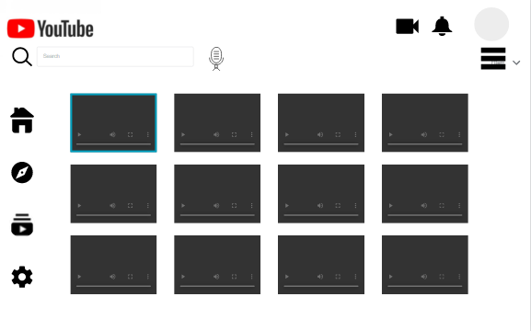

**Pic 1.1**

After clicking the button highlighted below,

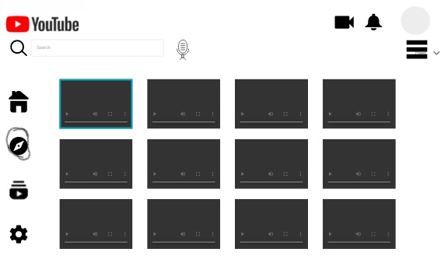

The following screen will appear,

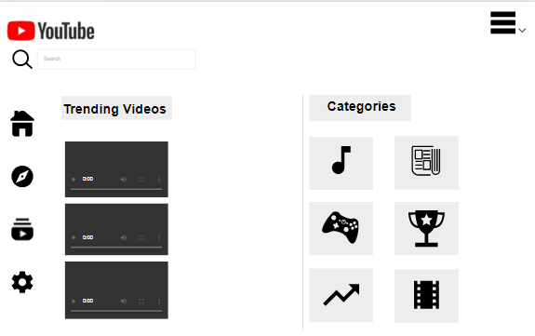

After clicking any video from the Pic 1.1, the following interface will appear.

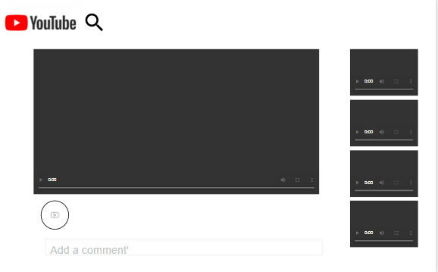

And after clicking the search button the interface will look like this:

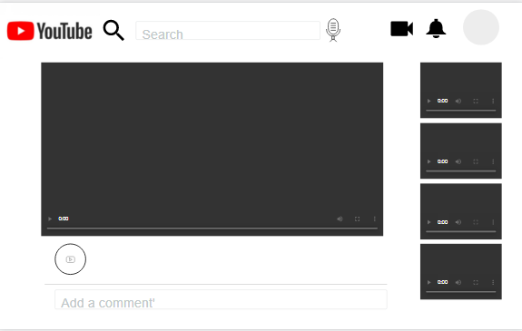

After searching something from the search bar following interface will appear.

